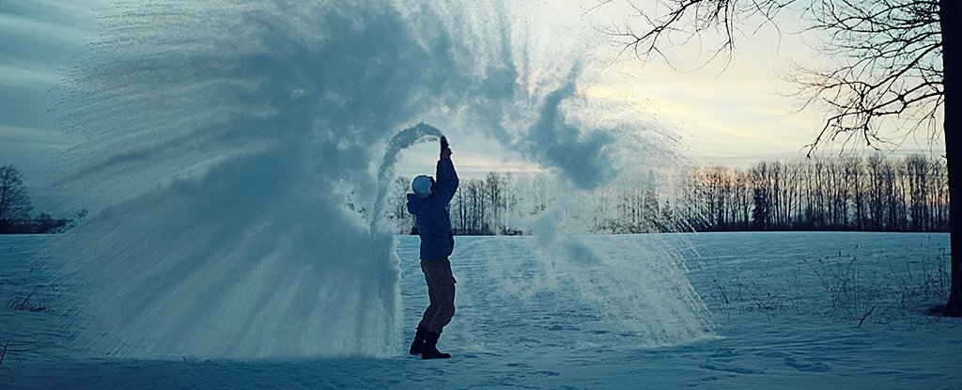

The effect of initial temperature on the time taken by water to reach 0°C

Maninder Singh Dhanauta

June 1, 2018

MDM 4U

Mrs. Rumsey

**Table of Contents**

Summary …………………………………………………………………………………….. 2

Background ………………………………………………………………………………….. 3

Problem ………………………………………………………………………………..…….. 5

Plan ………………………………………………………………………………………….. 6

Data ………………………………………………………………………………………….. 8

Analysis ……………………………………………………………………….……….…….. 8

Conclusion ………………………………………………………………………………….. 20

Bibliography …………………………………………………………………….………….. 21

Appendix …………………………………………………………………………….…….. 21

**1. Summary**

In this report, I tested the legitimacy of the Mpemba effect. The Mpemba effect states that under some conditions, hot water freezes faster than colder water. I was going to see the effects of impurities in water but my data was skewed so I could not make that comparison. I took note of the amount of water lost after each trial to see if that played a significant role. The final sub-question I looked at had to do with the paradoxical nature of this effect. Does boiling water take the same time to freeze once it has reached 25°C compared to a sample that starts at 30°C. I place 2.5 ounce of water into 5 Styrofoam cups. Each cup has its own temperature sensor hooked up to a microprocessor that log ever time the temperature change is significant enough. As a result, I have collected over 15000 pairs of data. I used this to explore the main secondary question. It turns out the placement of the cups effected the time it took to freeze the sample. This limited me from freely comparing all the measurements of time. I had to dismiss the fact that tap water froze slower that distilled water. Despite that, I was able to justify the combining of 2 sets of data. The justification comes from the analysis of the independent variable, initial temperature. The results from the experiment slightly favouring the Mpemba effect, although I would be reluctant since I had no data points beyond 90°C. I also ruled out water loss as a cause of this effect since I could not even measure it. Another conclusion I came across was that a warmer sample would freeze faster than a cooler sample if a timer was started once both samples reached a common temperature. This means the rate of cooling of a hotter sample tend to be faster at any given temperature than the rate of cooling of a colder sample. This does not mean that hotter samples of water will freeze faster than colder samples, they have a longer way to go. Also, even though some warmer temperatures freeze faster than some colder temperatures, the time it takes to boil the water takes away from any practical applications of this result.

**2. Background**

This experiment is inspired by the Mpemba Effect. It states that under certain conditions, warmer samples of water have been observed to reach freezing before cooler sample. To be exact:

“There exists a set of initial parameters, and a pair of temperatures, such that given two bodies of water identical in these parameters, and differing only in initial uniform temperatures, the hot one will freeze sooner.” [1]

The Mpemba Effect is named after its discoverer, Erasto B Mpemba. He noticed this effect as a kid when he was making ice-cream. At his Tanzanian school, all the boys would rush for a spot in the refrigerator to make their ice-cream. Once, he was late. In order to secure a spot, he broke the procedure and placed his boiling milk into the refrigerator instead of cooling it down. He later saw his ice-cream froze before all the other boys’. When he approached his teachers, he was ridiculed, but after conducting the experiment in front of them, they dismissed it as useless facts. This fact caught the attention of the physicist D.G. Osborne during one of his visits to Mpemba’s school, where Mpemba asked him about it. He conducted the experiment in a lab and to his surprise, the warmer water consistently froze quicker. [2]

This effect is rather non-intuitive. Boiling water has more energy than cooled water, so the cold water should always freeze first. Also, even if the boiling water cools more rapidly, at some point it would reach the temperature of the cool water, beyond which it should take the same amount of time plus the time it took to reach that temperature. What a paradox!

It is not completely understood why this is the case, granted that this topic is not the focus of intense scientific research. Some working theories are:

* Evaporation: Evaporation is an endothermic process, meaning heat can be lost to surrounding. Also, less water would need to be cooled.
* Convection: Warmer water would have greater temperature differences between top and bottom, resulting in convection and accelerating heat transfer.
* Thermal conductivity: Warmer containers may melt the frost below, providing the cup with better contact with the surface
* Solutes: Thing like minerals and salts in water effect freezing.

Along with other stuff beyond my comprehension (such as dissolved gasses, hydrogen bonding, crystallization etc.)1

**3. Problem**

The main thesis of this report is to find whether there is a relation between the initial temperature of water and the time it takes the sample to reach freezing. Freezing will be defined as the first time the sample reaches 0°C. All known factors other than temperature (volume, containers) are held constant (see **Plan** for details or experiment)

The effect of impurities on the time to freezing was going to be investigated. Throughout the experiment, the loss of water through evaporation will be recorded to see how significant it is. An additional analysis will be done to probe the paradoxical nature of this effect, to see if after placing the sample in the fridge, at some mutual temperature, does the sample take the same time to reach freezing from that point, regardless of its initial temperature.

My hypothesis is that warmer water will take longer to reach 0°C because it contains more energy to start with. Also, since water is known to have high specific heat capacity, impurities in the tap water will cause it to reach 0°C in the same or less time required by distilled (the impurities most likely have lower heat capacities).

I expect temperature vs time to freezing to be a moderate positive correlation (higher temp=longer time) for all water samples, a strong correlation would be hard to produce because of my equipment. I expect the time taken by samples at the same temperature will be in the order: distilled> tap.

The population is every temperature from 0°C to 100°C but I will be only analyzing every fifth(ish) degree ranging from 10°C to 100°C. My independent variable will be the initial temperature of the water and my dependent variables will be the time taken to freezing and water loss.

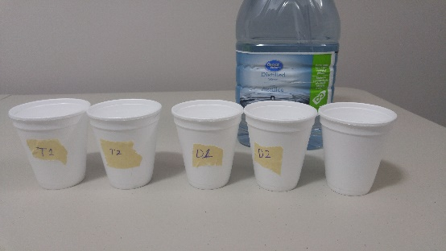**4. Plan:**

Material:

* 5 waterproof temperature probes.
* 1 microprocessor (Arduino) and breadboard
* Distilled and tap water.

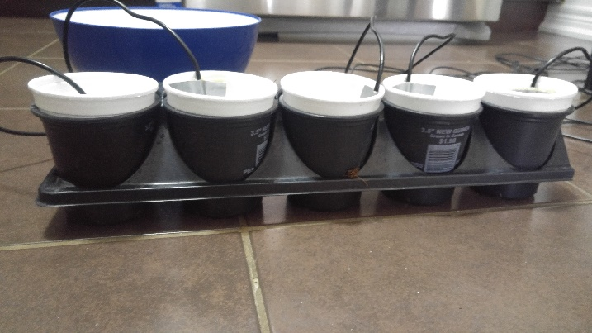

**This one isn’t taped on purpose**

* 5 Styrofoam glasses
* 1 flower tray

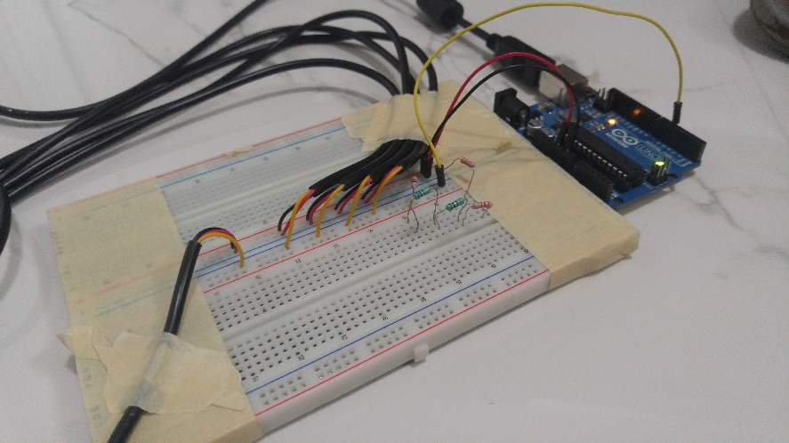

**Probes**

This one also used to aid in warming the water to right temperature

Procedure:

* Cool or heat the water slightly beyond the desired temperature.
* Quickly transfer exactly 2 ounces of distilled/tap water to designated cups using a dropper.
* Run the program and quickly place the tray

Note: Even if though the temperature may change by the time the water is placed, by running the program the instance I place the tray assures I receive the true initial temperature.

To make my life easier, I deployed my knowledge about electronics and coding that I learnt from Mr. Charles and Mr. Belton over the years. To measure the temperatures, I was using temperature probes (with 0.01°C accuracy) and an Arduino (a microcontroller) that communicated with my laptop and sent data relating to the current temperature of the water. The Arduino was programmed to send data (formatted: cup #, time(sec), temp (°C) ) after the temperature changed significantly or reached 0°C. I had 3 other programs used to decipher this “raw” data so I could manage it easily. This is primary data since I will be collecting it.

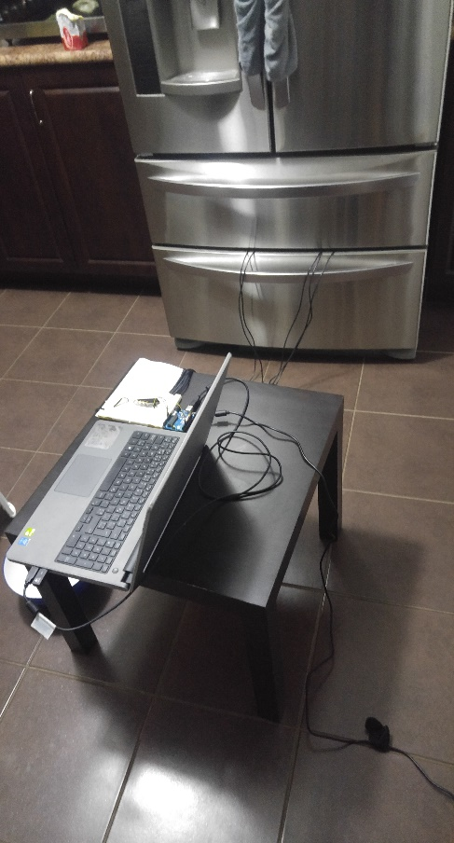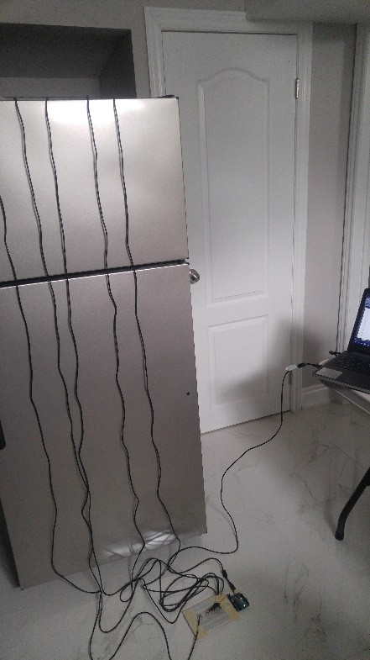I faced a few issues in this experiment. At first, I was using my old fridge in my basement. Turns out, old fridges are very bad at keeping a consistent temperature. So, I had to use my relatively newer fridge (ALL measurements were taken from new fridge):

The major flaw, however, was that some cups received direct impact of the cooled air. This realization came to me a little late, after I observed that cup labeled T1 was always the last one to freeze. For this reason, it would be unfair to combine or compare results from different cups (will be addressed in my analysis). The good news is that all the cups where always placed in the same spot, except this ONE time (only once) I, absentmindedly, exactly reversed the order of them (will be indicated in my analysis). Full disclosure.

Under these new developments, before looking at the data, I hypothesis that the average values of time taken will be the least for D1 and the most for T1

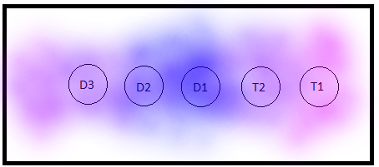

Fig. A depiction of the placement of the cups inside my fridge. The cups were aligned right. Blue represents the colder regions.

**5. Data**

See Appendix.

**6. Analysis**

First, let’s deal with the bias discussed in the previous section:

|  |  |  |  |  |  |
| --- | --- | --- | --- | --- | --- |
|  | D3 | D2 | D1 | T2 | T1 |
| Mean TTF*(in sec) | 3232 | 3287 | 3085 | 3360 | 3732 |
| Mean Temp(in °C) | 52.36 | 52.95 | 52.75 | 50.87 | 51.46 |

TTF= time to freezing

This analysis shows the average time it takes for 2.5 ounces of water to reach freezing. As predicted D1 has the lowest TTF while T1 has the highest. If it were to be argued that tap water may be meant to have a higher TTF and that there is no bias, the question would become why mean T2 and T1 are so far apart. This is clear indication that the bias exists.

But to measure how significant the bias of positioning is, I have I included the mean temperature. Consider D3 and D2. The mean temperature and TTF for D3 are both less than D2’s. This only makes sense (also their TTF are pretty close). So that means D2 and D3 are comparable. The mean temperature of D1, however, lies between D2’s and D3’s yet the mean TTF is significantly lower (because is closest to cooling system). This means D1 is not comparable with D2 or D3. T1 and T2 are not comparable within themselves either. The remaining issue is if T1 is comparable with D2 or D3. This is hard because it would be assuming the expected mean TTF given the mean temperature 50.87°C. For example, I could say that a difference in 1.5°C resulting in a difference of 130 seconds seems reasonable, thus comparable. But since TTF is the property I am measuring and that I have no other comparable T measurements, I cannot make this assumption. To play it safe I will say tap and distilled water is not comparable. Because of the inconsistencies in the environment, I cannot proceed to compare tap water to distilled water. But just for the sake of it:

|  |  |  |
| --- | --- | --- |
|  | Tap | Distilled |
| Mean TTF (in sec) | 3546 | 3201 |

This suggests tap water takes longer to freeze but I would be reluctant to accept that because both tap water cups were the furthest away from the cooling system.

If I choose to exclude the trial where I flipped the ordering, it would not do anything significant since it occurred around 62.5°C and the TTF was higher than the average. Excluding it would only bring the average down for all cups and we still couldn’t compare cups. So, I will leave it in for now. The flipping of ordering can, however, be used to further support that position is a factor in the TTF:

|  |  |  |  |  |  |
| --- | --- | --- | --- | --- | --- |
|  | D3 | D2 | D1 | T2 | T1 |
| @62.5°C  TTF (in sec) | 4112 | 4080 | 3848 | 3777 | 4204 |

The order of the time is: T2 < D1 < D2 < D3 < T1. Although T1 is still takes the longest time to freeze, it is not that far from D3, the other extreme ended cup. The time difference is less than 100 seconds, compared to the 500 second time difference in the average. This may suggest that tap water takes longer to freeze but this is only a single anomaly I am observing.

Next, I will measure the spread of the data:

|  |  |  |  |  |
| --- | --- | --- | --- | --- |
|  | D3 and D2 | D1 | T2 | T1 |
| Std. Dev. for time | 951 | 820 | 981 | 971 |
| Std. Dev. for temp | 25.2 | 25.15 | 26.4 | 26.1 |

Despite there being the bias, the measures of spread can still be compared, just not combined. This is because I am assuming if the cup is at the end (meaning on average, it takes longer to freeze), all the data points will be shifted over linearly without being spread out. It seems that all the distilled water sample freeze closer to the average time, at least when compared to tap water. I found the standard deviation for the temperatures to measure the significant of the std. dev. for time. The std. dev. for temperature is an extraneous variable, just like the average temperature in the last section. a higher std. dev. for temperature will naturally result in a higher std. dev. for time. D1 has a smallest deviation for both measurements, which makes sense. Both deviations for T2 and T1 very close and are ordered similarly. For this reason, to say distilled water sample freeze closer to the average time would be wrong since the deviation in the temperature is also smaller. The standard deviation tells me how confident I should be in using the average time to freeze for practical purposes. Clearly, the averages are very spread out, so it is not a good indication of the time it will take, for example, ice cubes to freeze. I used the average as a way to compare the relative temperatures and times. In that case, using the average is justified.

Choosing water loss as a secondary question was a poor choice because the water loss so insignificant that I could not measure it with my dropper. For this reason I am confident that water loss cannot be a significant factor of for the time it takes the sample to freeze.

Here are the individual graphs for each cup describing the relation between the initial temperature and time it takes to freeze:

I will justify my choice of the parabola to represent the curves. First, let’s eliminate the line. It makes sense the water at higher temperatures will drop the first few degrees faster than the last few degrees. Because initially the temperature difference is significantly higher, at the start, water will cool more rapidly. For this reason, I believe that a linear fit is inappropriate. Clearly, the relation was a curve that would flatten out, even my data points suggested that. I am now left with the parabola and the logarithmic. Choosing a parabola would mean the time peaks at a certain temperature and then starts to drop. Choosing a logarithm would mean that time never peaks, just does not change significantly. Depending on what I choose, my analysis would either support the Mpemba effect or oppose it. For this reason, I made the decision objectively. The parabolic fit gave a better R2 value. Another reason for choosing the parabola is because I can set the intercepts to (0,0). I cannot do that with logarithms (excel will not allow so). Point (0,0) should be included in the model equation because at 0°C, it takes 0 seconds to reach freezing. Also, the parabola is more evident than the logarithm in all graphs except for D1.

The average of all the R2 values is around 0.8191 with the lowest being 0.7756. This indicates a strong correlation. The most naïve conclusion would be that the TTF eventually does start reducing. The time peaks at around 70°C and starts going down. This would, to a certain extent, support the Mpemba Effect. The problem is that even if we went with logarithmic fit, it would still be a strong correlation. Also, even if the fit is truly parabolic, because the vertices are near 100°C and the parabolas are compressed, does it truly mean the temperature will be going down? This issue could have been resolved if I had measured TTF from 90°C+. Rereading my plotted data will show that I didn’t go beyond 90°C. The main reason for this was because by the time I was done pouring the boiling water, it would settle around 80°C. I tried a couple times but could not go beyond 90°C. That is way there is a slight cluster of points around 80°C. Another way to resolve this issue would have been to collect enough data. Unfortunately, all my data points got divided up because of the unexpected location issue. Despite this, I will combine D2 and D3 from the distilled water measurements and all the tap water measurements and graph them. I will then gauge their reliability.

In both cases, a parabolic fit yields the highest R2 value, but it is not significantly higher.

For reasons stated in the previous paragraphs, even though the combined tap water graph has a higher R2 value, I will not give it as much weight as the combined distilled water graph. Since I have more data suggesting a parabolic shape, I am more confident in my decision. Also, once again, the TTF peaks at around 70°C. Although it is not a strong indication that the time would decrease, it certainly suggests so.

Just to make the data more appealing and understandable, I will make a histogram. Notice that the intervals 22.495-27.495 and 37.495-42.495 have no data to be represented (it is not 0 seconds).

This histogram nicely summarizes the average TTF for each interval for the comparable distilled water samples. As you can see, the bars gradually stop increasing in height. You can kind of see at the end that the bars may or may not start decreasing. If I had more data beyond 90°C, it would have confirmed the parabolic shape. The intervals 22.495-27.495 and 37.495-42.495 have no data in. Do not confuse it with being 0 seconds. There is no point of making a histogram for tap water because no average would be taken. The T measurements are not comparable and each individual T measurements only contain 19 datapoints, and I have 20 intervals, making a histogram redundant.

Although the graphs above are made from 95 pairs of data points, I have collected about 15000 pairs of data point, each representing the temperature at a certain time after the trial began. These were collected to answer the paradoxical nature of the Mpemba Effect. If boiling water eventually reaches 70°C, beyond which it should continue at the same rate as water initially at 70°C. Here is the graph and I will explain how it is read.

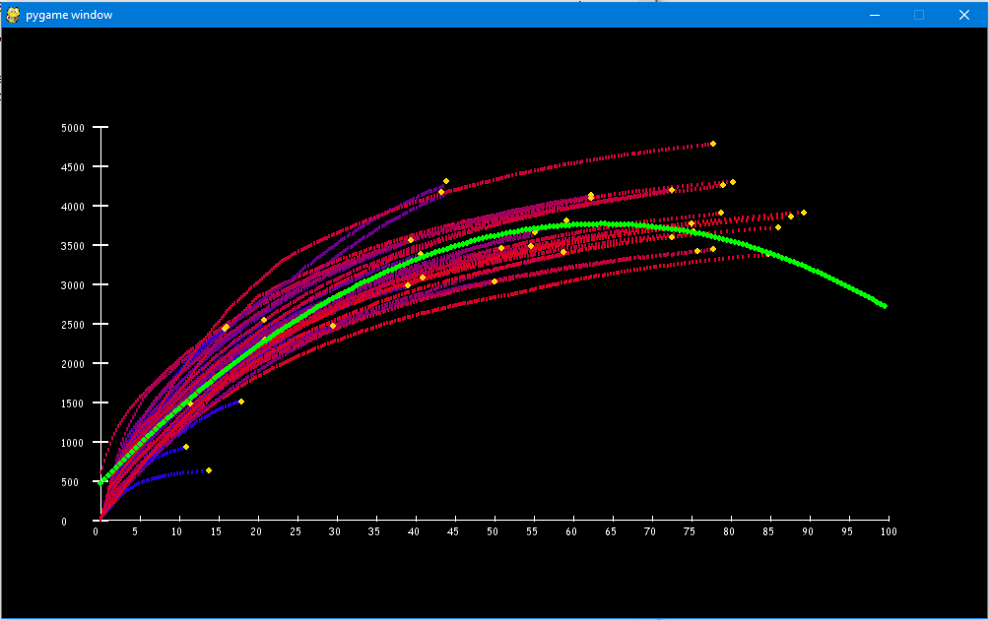

Registered Temperature (°C)

Time to freezing (sec)

Every Logged Data Point for cup D2 and D3

Since I have every instance of the whole process saved on a file, I produced this graph via code. It is colour coded to provide ease of analysis. The redder the line the hotter its initial temperature. I’ll give a brief example as to how to read. Choosing 70°C as the temperature, every sample with initial temperature greater than or equal to 70°C must at some point be 70°C. Every point above 70°C represent the time taken for that specific trial to reach freezing from the moment it reached 70°C. The yellow dot would represent the trials that actually started at 70°C. The green parabola is the parabolic fit (I got the equation from excel). Unfortunately, the blue was rendered behind the red and some quality was lost while pasting it onto word. Here is a graph with the colder temperatures rendered after (I only did D2 and D3 because those are the only comparable datasets):

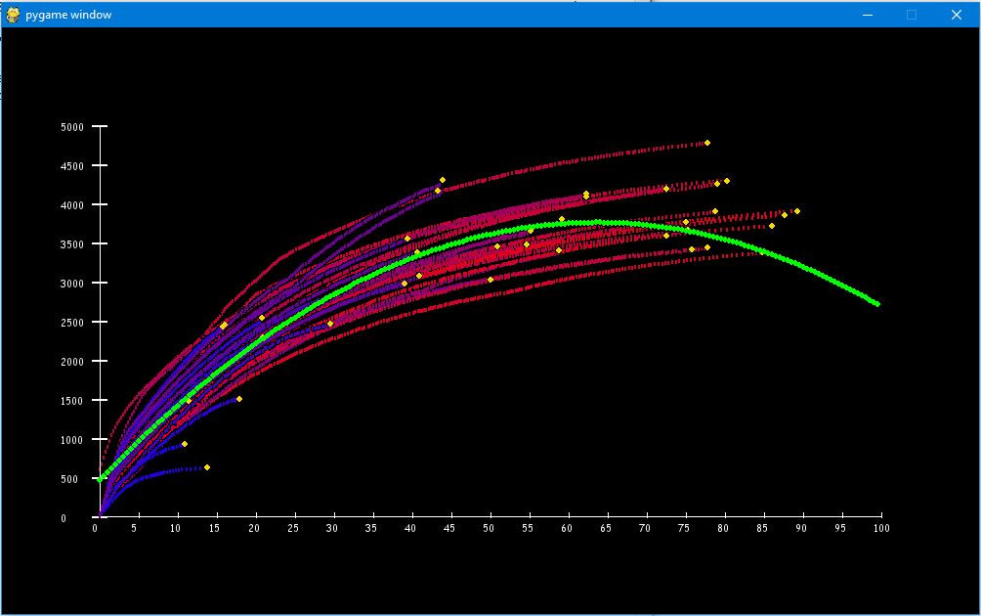

Registered Temperature (°C)

Time to freezing (sec)

Every Logged Data Point for cup D2 and D3

Here is the excel version of it, with a parabolic fit with the equation and R2 value:

Clearly, the TTF it takes from a certain temperature varies depending on its initial temperature. Most of the red lines fall below curve of best fit while most of the blue lines are fall above the curve. Start timing from a common temperature, samples with colder initial temperatures took longer to reach freezing vs samples with higher initial temperatures. This does not mean that hotter samples should freeze faster; it still takes time to reach that common temperature.

**7. Conclusion**

Although not completely conclusive, the experiment suggests the time taken for a sample of water to freeze does peak and beyond that peak, the time starts to decrease. This means higher temperatures beyond the peak should freeze faster. Since Mpemba Effect states that warmer water freezes faster than colder water under certain conditions, maybe my fridge environment was not ideal to make the differences clear (fridge temperature etc.). Also, a warmer sample would freeze faster than a cooler sample if a timer was started once both samples reached a common temperature. This means the rate of cooling of a hotter sample tend to be faster at any given temperature than the rate of cooling of a colder sample. This does not mean that hotter samples of water will freeze faster than colder samples, they have a longer way to go. I also found that tap water froze slower than distilled water, but this result is to be dismissed. Water loss has been ruled out to play a significant role since it was not even measurable. Despite the lack of comparability, by analyzing the independent variable, I was able to justify the combining of 2 data sets.

The most obvious bias is the positioning of the cups messed up the comparability of the datapoints. The placement increased or decreased the cup’s exposure to the cooling system of the fridge, resulting in certain samples freezing faster/slower than the others. Another realistic bias could occur at the sensors. While testing the sensors, each sensor read a slightly different reading for the same sample. The largest difference was 0.3°C. Although not significant, it affects the measurements none the less. There are limitations with my experiment as well. My samples are too small to generalize beyond an ice cube. I was also unable to measure temperature above 90°C.

To get rid of the issue of positioning, the simplest but most time-consuming solution would be to run only one test at a time. That way the position is always the same. This would also get rid of the sensor calibration issue since the same sensor will be used every time. Like mentioned before, although realistic, it would become very time consuming. To do 100 trial will take 3200*100/3600=88.9 hours plus boiling time. Even doing it 5 at a time, it took me about 25 hours over a period of days. A work around would be to do 2 trials at the same temperature where you reverse the order in the second. It would let you test multiple cups at the same time while having a less bias average, the flipping cancel each other out. To make measurement above 90°C, I would need to by an electric kettle that could keep the water boiling as I am pouring it. The problem was that as I pulled the boiling water off the stove, it instantly started cooling.

**8. Bibliography:**

Jeng, M. (2006). The Mpemba effect: When can hot water freeze faster than cold? *American Journal of Physics,74*(6), 514-522. doi:10.1119/1.2186331

Mpemba, E. B., & Osborne, D. G. (1979). Cool? *Physics Education,14*(7), 410-413. doi:10.1088/0031-9120/14/7/312

**9. Appendix:**

See attached file.

1. <https://arxiv.org/pdf/physics/0512262v1.pdf>
2. <https://africanlegends.files.wordpress.com/2010/06/mpemba_the-mpemba-effect1.pdf>